**Cloudera - Kerb Setup**

This is all setup on Cloudera version 516.2. Detailing the setup that I have done in order for Kerberos to work on the VM.

# Setup an MIT Kerberos environment

* I setup a Kerberos environment on the VM which already hosts the Cloudera Manager Server and agent.
* The following files have been edited on the conf file
  + /etc/krb5.conf
  + /var/kerberos/krb5kdc/kadm5.acl
  + /etc/krb5.conf
* Edited the /etc/krb5.conf with the following values.

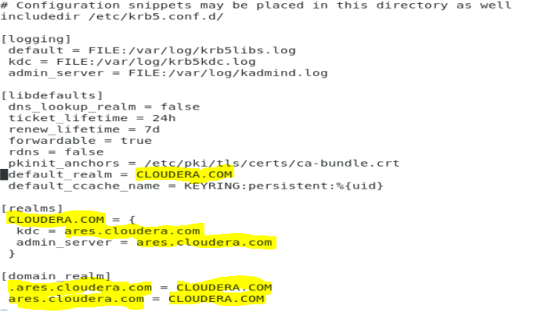

* Edited the /var/kerberos/krb5kdc/kdc.conf with the following values.

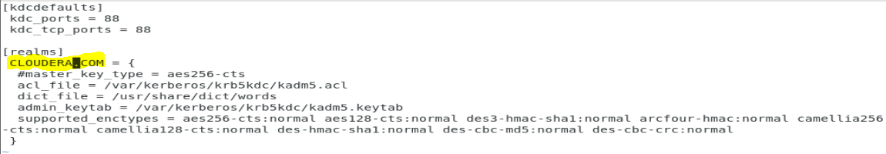

* Edited the /var/kerberos/krb5kdc/kadm5.acl with the following values 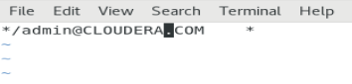
* Created the KDC Database to hold sensitive Kerberos data running the following command
  + kdb5_util create -r CLOUDERA.COM -s
  + provided a simple pass key after running command.

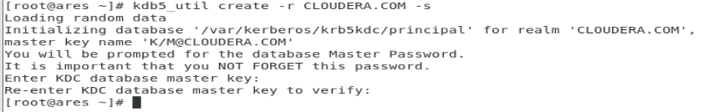

* Logged into kadmin running the following command and created the following principals
  + Kadmin.local
  + addprinc [root/ares@CLOUDERA.COM](mailto:root/ares@CLOUDERA.COM)

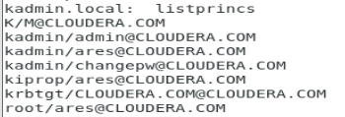

* Started the following services
  + systemctl start krb5kdc.service
  + systemctl start kadmin.service
  + systemctl enable krb5kdc.service
  + systemctl enable kadmin.service

# Install JCE for Kerberos

* I Downloaded the JCE JDK7 Policy zip file from Oracle
* Unzipped the folder to the following path using the command
  + unzip -o -j -q /home/naledi/Downloads/UnlimitedJCEPolicyJDK7.zip -d /usr/java/jdk1.7.0_67-cloudera/jre/lib/security/
* Restarted Cloudera manager and agent.
  + Systemctl restart cloudera-scm-server
  + Systemctl restart cloudera-scm-agent
* Log into cloudera manager to install the JCE Policy file
  + Navigate to Administration>Security

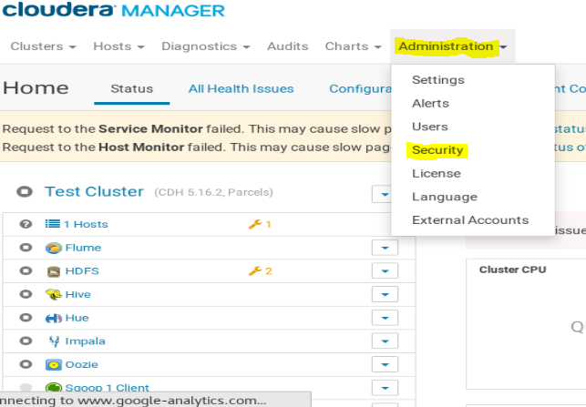

* Ran the Security Host Inspector and found the JCE Policy file installed.

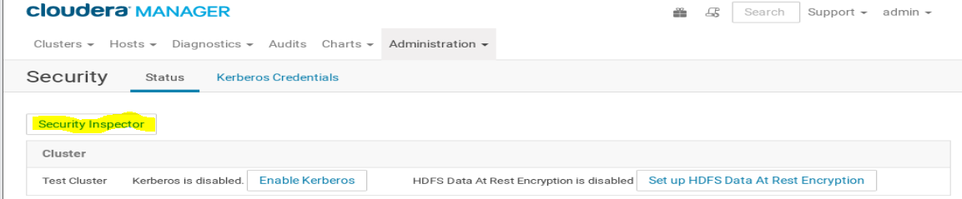

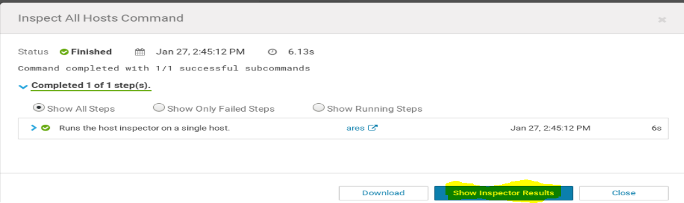

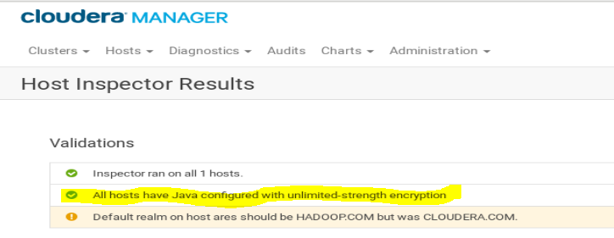

* As you can see from the above images, JCE installation was a success.
* Checked the encryption type used for Kerberos using by doing the following.
  + Added the following princ
    - Addprinc [test/ares@CLOUDERA.COM](mailto:test/ares@CLOUDERA.COM)
  + Ran the following command to open Kerberos session
    - Kinit [test/ares@CLOUDERA.COM](mailto:test/ares@CLOUDERA.COM)
  + Ran the following to see if session was opend and to also check the encryption type
    - Klist -f
    - Klist -e

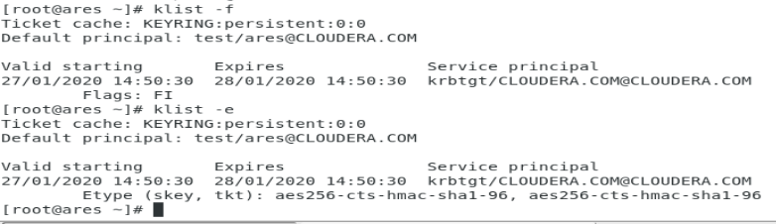

# Create Kerberos Principal for Cloudera Manager.

* Created the following principal with the following command
  + addprinc -pw pass [cloudera-scm/admin@CLOUDERA.COM](mailto:cloudera-scm/admin@CLOUDERA.COM)

# Enabling Kerberos using the wizard.

* Added the following line in the following file /var/kerberos/krb5kdc/kdc.conf
  + max_life = 1d
  + max_renewable_life = 7d

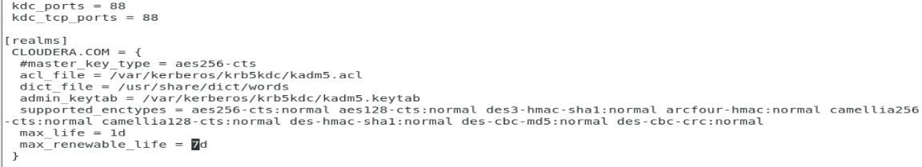

* installed the following package
  + sudo yum install openladap-clients
* Went to Administration>Security and clicked on Enable Kerberos

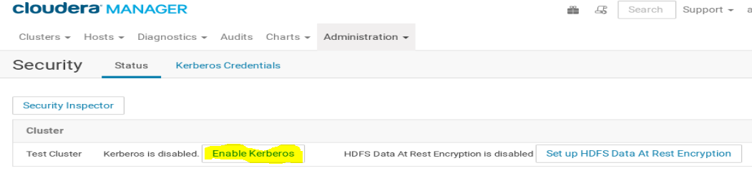

* Checked all the boxes in the Getting Started Wizard. All has been configured

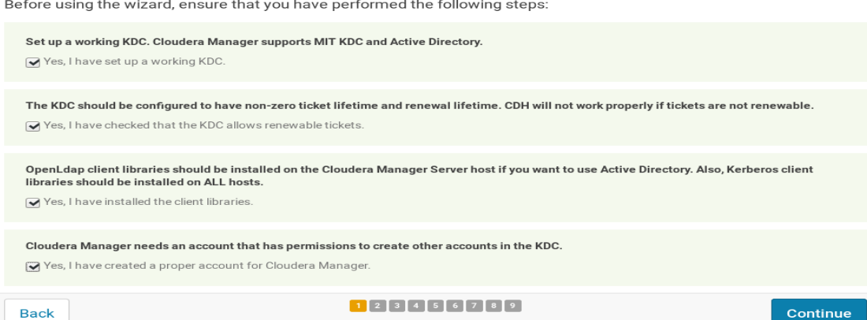

* Edited the following values on the Setup KDC page

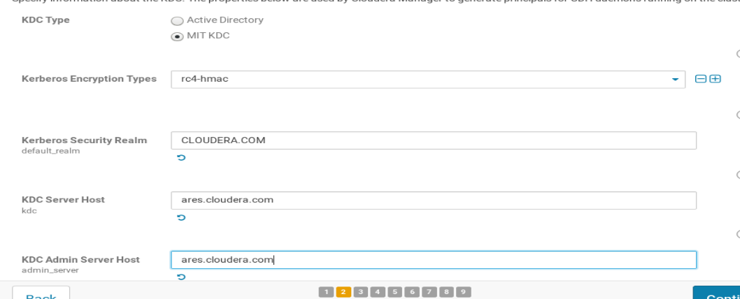

* Checked the “Manage krb5.conf through Cloudera Manager”checkbox. Didn’t edit any values, left them as default.

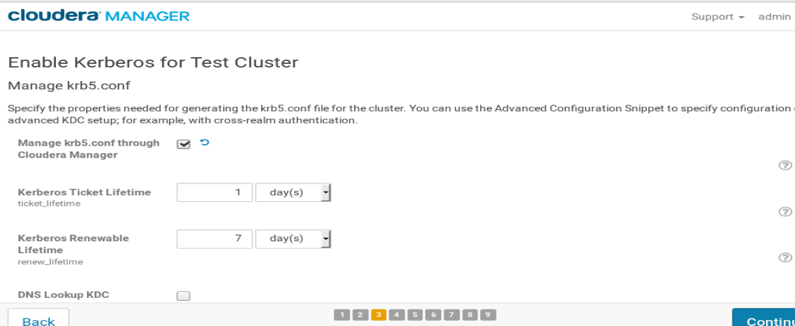

* Provided the [cloudera-scm/admin@CLOUDERA.COM](mailto:cloudera-scm/admin@CLOUDERA.COM) principal and was a success.

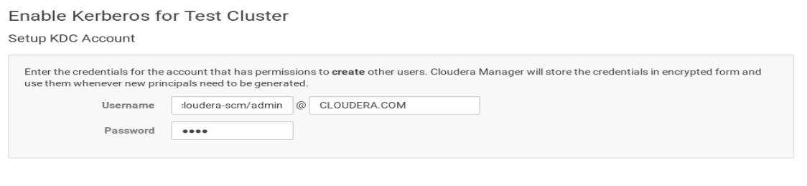

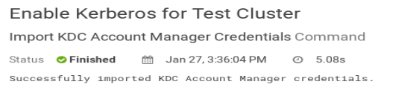

* Left the following as default

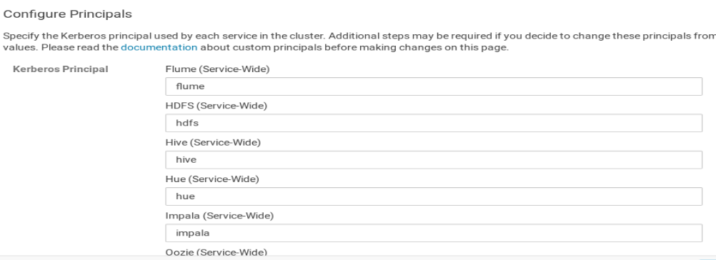

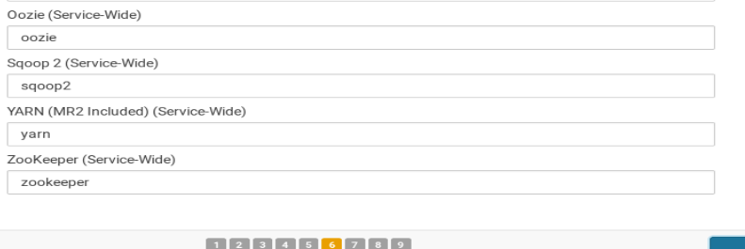

* Restarted the cluster

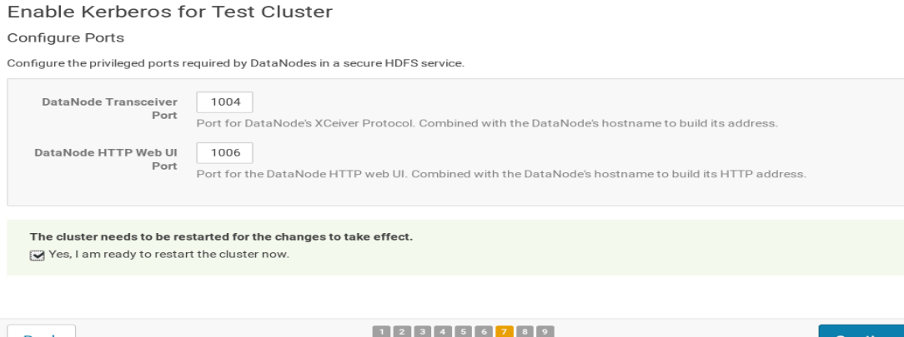

* Wizard is complete and Kerberos has been enabled successfully.

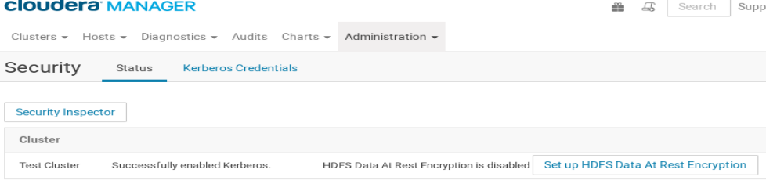

* The principals are generated as the following

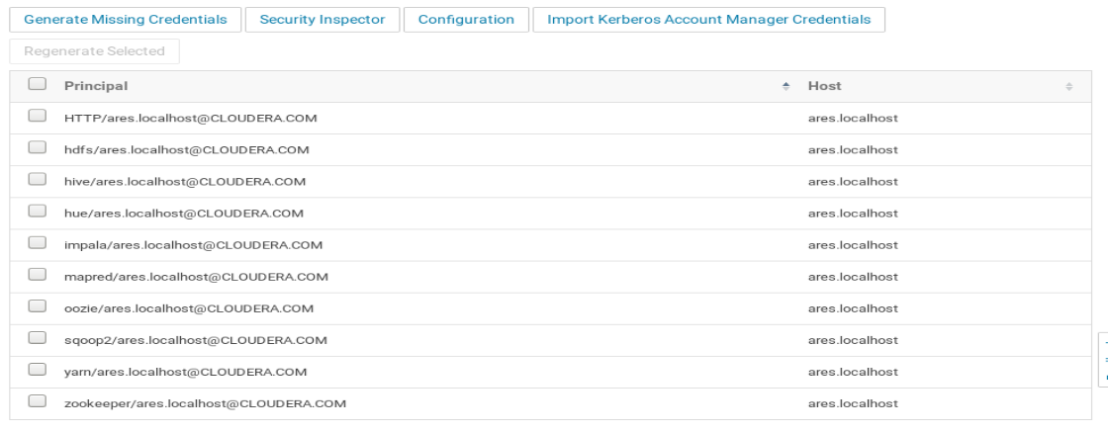

# Create the HDFS Users

* The default hdfs user has been disabled, so I used the cloudera manager to rename the HDFS Supergroup name to kerb on the HDFS service Configuration.

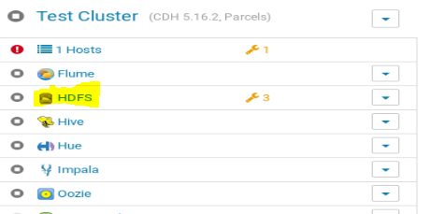



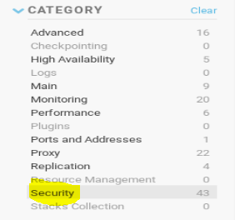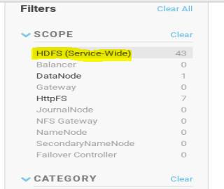



* Added new princ in kadmin shell
  + addprinc [kerb/ares@CLOUDERA.COM](mailto:kerb/ares@CLOUDERA.COM)
  + password is “pass”

# Prepare the Cluster for each user.

* Created user naledi folder in hdfs
  + 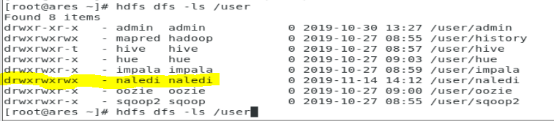
  + Created naledi princ in Kerberos and was able to run hdfs command with the naledi folder in the hdfs user directory.
    - 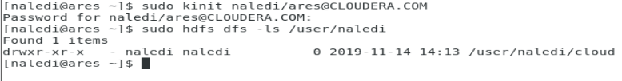

After all of this, I can confirm that Kerberos is working and I am able to run hdfs commands in Hadoop. Still need more testing with other services like Hive, but I’m confident with this setup and might be a way forward to reach a more governance and compliant Cloudera Cluster.